Quiz Review: Triangle Trig

- A triangle has an acute angle such that$sinθ=\frac{3}{8}$. Find the other five trigonometric ratios.

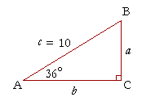
- Solve the triangle.

- John is standing 20 feet from a tree. The angle of elevation to the top of the tree is 15º. There is a tree house on top of the tree and the angle of elevation to the top of the tree house is 18º. How tall is the tree house?

- From the top of a barn 25 feet tall, you see a cat on the ground. The angle of depression of the cat is 40º. How many feet, to the nearest foot, must the cat walk to reach the barn?

