AP Statistics
Notes 5.1

ACTIVITY: The “1 in 6 wins” game
As a special promotion for its 20-ounce bottles of soda, a soft drink company printed a message on the inside of each bottle cap. Some of the caps said, “Please try again!” while others said, “You’re a winner!” The company advertised the promotion with the slogan “1 in 6 wins a prize.” Seven friends each buy one 20-ounce bottle at a local convenience store. The store clerk is surprised when three of them win a prize. Is this group of friends just lucky, or is the company’s 1-in-6 claim inaccurate? In this Activity, you and your classmates will perform a simulation to help answer this question.
For now, let’s assume that the company is telling the truth, and that every 20-ounce bottle of soda it fills has a 1-in-6 chance of getting a cap that says, “You’re a winner!” We can model the status of an individual bottle with a six-sided die: let 1 through 5 represent “Please try again!” and 6 represent “You’re a winner!”
- Roll your die seven times to imitate the process of the seven friends buying their sodas. How many of them won a prize? Write the numbers rolled in the table below.

- Repeat Step 1 four more times. In your five repetitions of this simulation, how many times did three or more of the group win a prize?
Trial Number | Roll 1 | Roll 2 | Roll 3 | Roll 4 | Roll 5 | Roll 6 | Roll 7 | Total Wins
1
2
3
4
5

- Combine results with your classmates on board. What percent of the time did the friends come away with three or more prizes, just by chance?

- Based on your answer in Step 3, does it seem plausible that the company is telling the truth, but that the seven friends just got lucky? Discuss this as a class.

From your text: “Chance behavior is unpredictable in the short run but has a regular and predictable pattern in the long run. This remarkable fact is the basis for the idea of probability.”
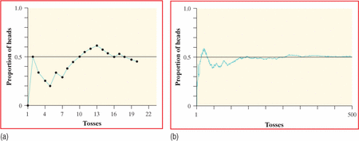
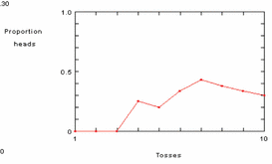

- How does the coin flipping applet demonstrate this?

The fact that the proportion of heads in many tosses eventually closes in on 0.5 is guaranteed by the law of large numbers.
The probability of any outcome of a chance process is a number between 0 and 1 that describes the proportion of times the outcome would occur in a very long series of repetitions.

What you should already know about probability:
- Any probability is a number between _____ and _____.

- If the outcome is certain, the probability is _____.

- If the outcome is impossible, the probability is _____.

- All possible outcomes together must have a probability of _____.

- The probability that an event does not occur is _______________ the probability that it will occur. (complement rule)

ACTIVITY: Investigating randomness
- Pretend that you are flipping a fair coin. Without actually flipping a coin, imagine the first toss. Write down the result you see in your mind, heads (H) or tails (T). Imagine a second coin flip. Write down the result. Keep doing this until you have recorded the results of 50 imaginary flips. Write your results in groups of 5 to make them easier to read, like this: HTHTH TTHHT, etc.

- A run is a repetition of the same result. In the example in Step 1, there is a run of two tails followed by a run of two heads in the first 10 coin flips. Read through your 50 imagined coin flips and count the number of runs of size 2, 3, 4, and so on. Record the number of runs of each size in a table like this:
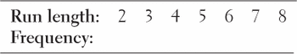

- Use Table D or technology to generate a similar list of 50 coin flips. Record the number of runs of size 2, 3, 4, and so forth in a table like this:

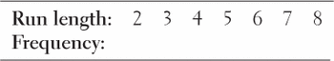

- Compare the two results. Did you or your calculator have the longest run? How much longer?

The myth of short-run regularity The idea of probability is that randomness is predictable in the long run. Unfortunately, our intuition about randomness tries to tell us that random phenomena should also be predictable in the short run. When they aren’t, we look for some explanation other than chance variation.
Examples:
- Roll a die 12 times and record the result of each roll. Which of the following outcomes is more probable?
123456654321 154524336126

- Hot Hand? Baseball great, Joe DiMaggio, had an amazing hitting streak in 1941. His career batting average was .325. After 50 consecutive games with hits, what was the probability of getting a hit during his 51st game?

The myth of the “law of averages” Don’t confuse the law of large numbers, which describes the big idea of probability, with the “law of averages” described here. The myth is that future outcomes must make up for an imbalance like six straight tails.
Coins and dice have no memories. A coin doesn’t know that the first six outcomes were tails, and it can’t try to get a head on the next toss to even things out. Of course, things do even out in the long run. That’s the law of large numbers in action. After 10,000 tosses, the results of the first six tosses don’t matter. They are overwhelmed by the results of the next 9994 tosses.

- Stoplight On her drive to work every day, Ilana passes through an intersection with a traffic light. The light has probability 1/3 of being green when she gets to the intersection. Explain how you would use each chance device to simulate whether the light is red or green on a given day.
- A six-sided die

- Table D of random digits

- A standard deck of playing cards

